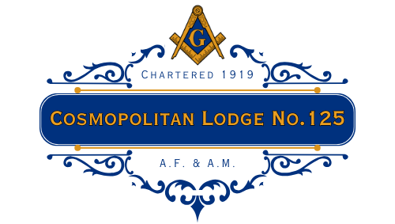

NOVEMBER 2026 TRESTLEBOARD

View from the East:
My Brothers,
With Thanksgiving approaching, November is a good time to think about what we are thankful for and how we can share some of that good fortune with others. At Cosmopolitan, we have several opportunities to do just that this month.
Our Lodge continues to find ways to give back to the community, whether through our support of the Downtown Evening Soup Kitchen (DESK) in New Haven, our new No-Shave November fundraiser and clothing drive, or our donation of food to support Steve Canada's Thanksgiving event. I'm proud that our Brothers continue to find ways to put our values into action and help those around us.
November will be a busy month in Lodge. On November 4, we'll be celebrating Brother Christopher Bushy as he receives a Grand Lodge Award. This event is open to the public, so please feel free to invite family and friends to join us. We'll also have our Lodge Leadership Dinner on November 10, Steve Canada's Thanksgiving dinner on November 14, an Entered Apprentice Degree on November 18, and our Lodge Thanksgiving Dinner on November 22. I hope to see many of you at these events as we continue our work together and welcome a new Brother into our Masonic family.
As we head into Thanksgiving, I want to thank each of you for the time, effort, and care you bring to Cosmopolitan. The strength of our Lodge comes from its Brothers, and the good we do together is one more reason to be proud of what we share.
Wishing you and your families a happy and healthy Thanksgiving.

Fraternally,
Bro. Joe

Upcoming Programs | Contact Information
Wed, Nov 4: Stated Communication with Worshipful Master Joseph K. Fried in the East. Br. Christopher Bushy will also be awarded with a Grand Lodge Award. The event will be Open to the Public. Meeting will start at 7:30pm; Attire for the meeting is tie and jacket.  Tues., Nov 10: Lodge Leadership DInner at Biagettis. Please contact WM Joseph K. Fried at (203) 927-0003 or josephkfried@gmail.com if you would like to attend.  Sat, Nov 14: Steve Canada's Dinner @ 5:00pm. Please bring a side to share with 4 people and food to donate.  Wed, Nov 18: Stated Communication and Entered Apprentice Degree with Worshipful Master Joseph K. Fried in the East. Meeting will start at 7:30pm; Attire for the meeting is tuxedos for officers, and tie and jacket for all others. Dinner at 6:30pm ($20 pp), reservations made with JW Asanish Kalyanasundaram.  Sun, Nov 22: Cosmopolitan Lodge Annual Thanksgiving Dinner. All are invited. Dinner at 6:30pm ($20 pp), reservations made with JW Asanish Kalyanasundaram.  Sun, Nov 29: Volunteer Opportunity with the Downtown Evening Soup Kitchen (DESK), where we are scheduled from 4:00-6:30pm. RSVP with RW Gary E. Cohen at (203) 530-6222 or garyec39@gmail.com  December  - Dec. 2 – Annual Meeting & Lodge Elections  - Dec. 16 – Stated Communication  - Dec. 23 – Anticipated Fellowship Dinner  - Dec. 27 – DESK Volunteering | Worshipful Master  Joseph K. Fried  (203) 927 – 0003  josephkfried@gmail.com  Senior Warden  RW Michael Abrahamson  (203) 395 – 2402  mabrahamson@earthlink.net  Junior Warden  Asanish (Ash) Kalyanasundaram  (360) 206 – 8544  asanish.k@hotmail.co.uk  Secretary  RW Gary Matican  (203) 410 – 9733  gmatican@yahoo.com  Lodge Email  cosmo125@ctfreemasons.net  Lodge Address  285 Whitney Avenue  New Haven, CT 06511  Mailing Address  Gary Matican, Sec.  40 Meadow Brook Place  Cheshire, CT 06410-4310
Cosmopolitan Lodge No. 125 Invites You to Celebrate Brother Christopher Bushy
Please join us on Wednesday, November 4, as we celebrate Brother Christopher Bushy and his recognition with a Grand Lodge Award.
This is a wonderful opportunity to recognize Brother Chris and share this special occasion with him. The event is open to the public, and family and friends are welcome to attend.
Let's show our support for Brother Chris and make this a memorable evening!
We hope to see you there!

Brother’s Birthdays

Richard A. Werner – 02 | Jon-Paul J. Venoit – 03 | Gary E. Cohen - 06
Lawrence D. Weiss – 08 | Anthany W. Reckart – 11 | Jerome D. Korman - 12
Michael M. Rosenblum - 13 | Murry H. Rubin - 14 | David A. Hutchings 16
Eugene M. Miller - 18 | Dominick J. Stabile – 18 | Joel Evans – 19
Mathew L. Lebow – 19 | Gary P. Merwede – 19 | Maxwell Stock - 19
Michael S. Weiner - 20 | Stuart M. Smith – 21 | Marc J. Dinerstein – 24
Jayson T. Ferron – 26 | Barry T. Schacht - 26

View from the West:
My Brothers,

With the arrival of November comes a season of giving thanks. In our Lodge, we have a great deal to be thankful for. This year, through the hard work of our Worshipful Master, officers, and all of our brothers, Cosmopolitan is a positive, vibrant lodge. Our calendars are full. Our joy is plenty. Perhaps most importantly, we have a group of interested and supportive brothers coming together to improve themselves in Masonry. I believe that we are not perfect but we can always strive for constant self-improvement in our journey together in masonry.

On Sunday, November 22nd, we are having our annual Thanksgiving Dinner, which is one of our biggest events of the year. I truly hope that you will join us as we give thanks for all that we share.

Brothers. It is also true that there cannot be times of renewal and growth without periods of sickness and distress. Please inform me or the other members of the sick-visiting committee of any brothers, family members, or friends who are unwell. Often, a telephone call or a visit from a Lodge brother is just what someone needs as they recuperate.

I look forward to seeing you, my brothers, in our lodge. The place where it is good and pleasant for brothers to dwell together in unity.

In Masonry,
Michael Abrahamson
RW Michael Abrahamson
Senior Warden

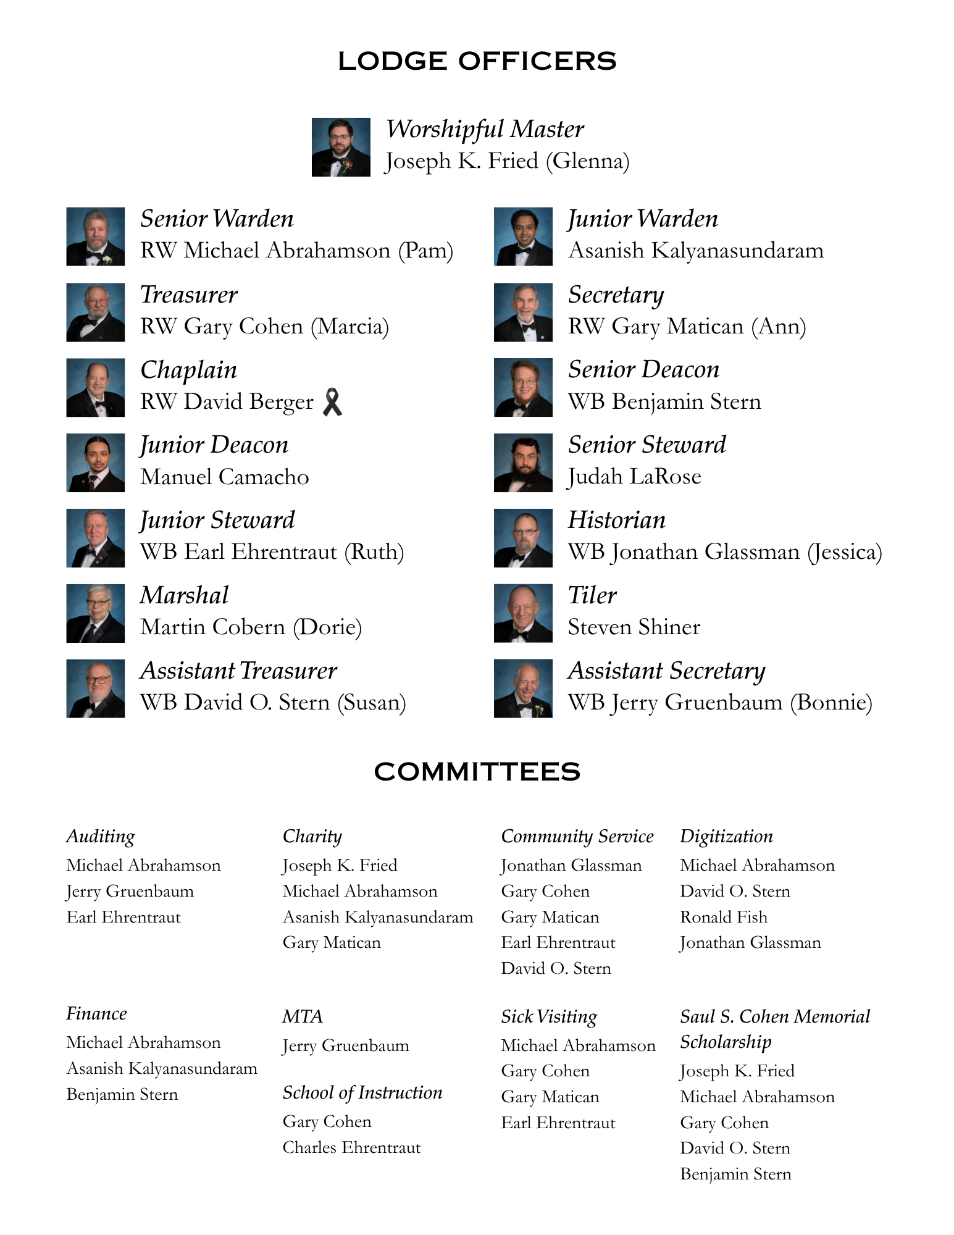
st Master’s of Cosmopolitan Lodge No. 125

*Jacob Caplan | 1919, 1923 | *Henry G. Smernoff | 1954 | Edward L. Goodstein | 1987
*Joseph E. Levy | 1920 | *Martin B. Gant | 1955 | *Michael L. Castroll | 1988
*Samuel I. Calechman | 1921 | *Simon Burres | 1956 | RW Martin L. Rudnick | 1989, 2002
*Benjamin F. Goldman | 1922 | *David Cohen | 1957 | *Harley O. H. Pretty | 1990
*Samuel J. White | 1924 | *Albert Gurewitz | 1958 | RW Gary Matican | 1991, 1995, 2003
*Nathan Smernoff | 1925 | *Marshall R. Weiner | 1959 | Bruce L. Lebow | 1992
*Manuel Kligerman | 1926 | *Herbert B. Goldberg | 1960 | *Richard L. Hecht | 1993
*Samuel M. Silver | 1927 | *Leo Gilden | 1961 | Bruce M. Backer | 1994
*Jacob N. Wolodarsky | 1928 | *Jordan Goldberg | 1962 | Gary P. Merwede | 1996
*Samuel W. Ritch | 1929 | *Gerald W. Brownstein | 1963 | Gary S. Spanierman | 1997
*Louis R. Hershatter | 1930 | *A. Robert Sotman | 1964 | *RW Arnold H. Freedman | 1998
*Julius White | 1931 | *Arnold Most | 1965 | *Edward S. Eby | 1999
*RW Irving Alpert | 1932 | George Weinstein | 1966 | Maier O.Fein | 2000
*Andrew N. Friedman | 1933 | *Irving Kegeles | 1967 | Phillip E.Cohen | 2001
*RW Samuel Platcow | 1934 | *Abraham B. Rosenberg | 1968 | David O. Stern | 2004, 2010
*RW Alex C. Hershatter | 1935 | *Morris Klein | 1969 | RW David E. Berger | 2005
*Benjamin D. Levine | 1936 | *William E. Weiner | 1970 | *William E. McGraw, Jr. | 2006
*John M. Chapnick | 1937 | *Chester M. Katzman | 1971 | Stuart M. Smith | 2007
*Joseph Weiner | 1938 | *Robert Tombank | 1972 | Roger Jackson | 2009
*Irving Rogers | 1939 | *Leonard Tombank | 1973 | Steven J. Elzholz | 2011
*Maurice Osber | 1940 | *Milton A. Hershatter | 1974 | RW Jason E. Morse | 2012, 2013
*Herman Alpert | 1941 | Richard A. Sugarmann | 1975 | RW Scott Bumps | 2014
*George J. Evans | 1942 | *Michael W. Winess | 1976 | MWPGM Bruce R. Bellmore | 2015
*RW Joseph Shure | 1943, 1944 | *Albert R. Blackman | 1977 | David M. Elkodsi | 2016
*Goodwin D. Wolff | 1945 | *RW Joseph Albert | 1978 | Randy S. Stevens | 2017
*Leon I. Horton | 1946 | RW Gary E. Cohen | 1979 | Jerry Gruenbaum | 2018
*Natt K. Sheinfeld | 1947 | Sidney J. Levine | 1980 | RW Michael S. Abrahamson | 2019, 2020
*A. Louis Phillips | 1948 | Ronald M. Dworkin | 1981 | Frederick A. Marotti | 2021
*Fredric M. Rosenstein | 1949 | Kenneth L. Dworkin | 1982, 2008 | Daniel D. DeVoe II | 2022
*Milton S. Holiner | 1950 | *Steven A. Ledewitz | 1983 | Charles G. Ehrentraut, Sr. | 2023
*William Ledewitz | 1951 | Robert S. Brooks | 1984 | Earl W. Ehrentraut | 2024
*A. Henry Mirel | 1952 | Joseph M. Cohen | 1985 | Benjamin G. Stern | 2025
*Harold P. Gessner | 1953 | Jeffrey A. Granoff | 1986
* Brothers who have entered the house not made with hands, eternal in the heavens.

Current Grand Lodge | Past Masters of Other Lodges
RW Timothy Vendetti  District Deputy, District 4A  RW Michael S. Abrahamson  District Deputy, District 4C  Associate Grand Tiler  RW Gary E. Cohen  Associate Grand Almoner, 4th District  WB Frederick A. Marotti  District Deputy at Large  Associate Grand Tiler  WB Scott Atkins  Associate Grand Marshal, District 4A  WB Daniel D. DeVoe II  Associate Grand Marshal, District 4C  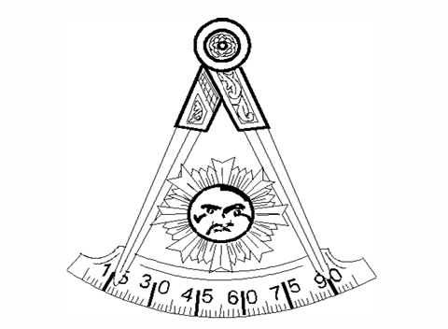 | RW Michael Abrahamson | Daytime #44 (2024)
 | MWPGM Gustaf Bodin | St. Alban’s #38 (1976), Ashlar #332 (2011)
 | MWPGM Bruce Bellmore | Olive Branch #84 (1981), Hiram #1 (1993)
 | RW Leonard Bucher | Widow Sons (1977), Hiram #1 (1995-1996), St. Alban’s #38 (2007)
 | RW Roger Cole | Meridian #77 (1976), Madison #87 (2006)
 | Steven Canada | Temple #16 (2011, 2013), Day Spring #30 (2016-2017)
 | Alan Friedman, Jr. | Annawon #115 (2003, 2013), Orang #143 (2009-2010)
 | Jonathan Glassman  Roger Jackson | Quinta Essentia #500 (2023-2025)  Temple Lodge #16
 | Bruce Liebman | Masonic Lodge of Research #401 (1997)
 | Frederick Marotti | Hiram #1 (2020)
 | RW Jason Morse | Quinta Essentia #500 (2019-2021)
 | Kevin Matsil | Meridian #77 (2003)
 | Kyle Podpolucha | Annawon #115 (2020)
 | Eric Silver | Temple #16 (2013)
 | Randy Stevens | Adelphi-Momauguin #63 (2002), Madison #87 (1985-1986, 1992)
 | Jon-Paul Venoit | Compass #9 (2005)
 | Timothy Wilkins | Hiram #1 (2015)

Cosmopolitan Lodge No. 125 Presents: No-Shave November!
This November, Cosmopolitan Lodge No. 125 is taking part in No-Shave November to raise money for the Downtown Evening Soup Kitchen (DESK) in New Haven.
Want to join the competition? The entry donation is $25, and we'll be awarding prizes for our Top Fundraiser and Best Facial Hair Transformation! Whether you're growing out your beard, trying a new look, or seeing just how far your facial hair can go, this is a fun way to support a good cause.
Not interested in joining the competition? You can still support the fundraiser with a donation of any amount! We've set up an online donation link so Brothers near and far can contribute, even if you don't live close enough to participate in person. Every donation helps DESK continue its important work supporting people in our community.
Donate here: https://deskct.org/cosmo

Help DESK with a Clothing Donation
In addition to our fundraiser, DESK is looking for clothing and other items to help adults experiencing homelessness. Because storage space is limited, they can only accept clothing appropriate for the current season.
For the colder months, DESK needs:
- Coats and boots
- Heavy socks
- Pants
- Long-sleeve shirts
Items needed year-round:
- Underwear
- Clothes hangers to help store and organize donations
DESK serves a population that is approximately 80% adult men, so men's clothing is especially helpful. Please make sure clothing donations are appropriate for the season.
If you have any questions about the fundraiser, please feel free to email me at josephkfried@gmail.com.
Let's show what Cosmopolitan Lodge can accomplish when we come together for a good cause. Thank you for helping us support our community!



