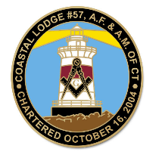
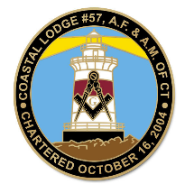
Stated Meeting of Coastal Lodge No. 57, A.F. & A.M.
Masonic Temple on Tuesday, February 18, 2025

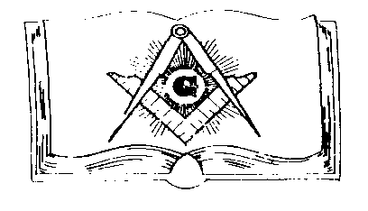
OFFICERS PRESENT WERE

W. M: Wor. Dante Pezzolesi
S. W.: Wor. Philipp Baumann Jr
J. W.: Wor. John Piper
Secretary:
Asst. Secretary: RW Phil Rathbun
Treasurer: Bro Waye LaBarre
Asst. Treasurer:
Chaplain: RW C. A. Duke
S. D.: Michael Northrup
J. D.: Tim Deveau
Marshal: Luis Guigni
S. S.: Gary Lassinger
J. S.: Greg Bromley
Asst. Steward:
Asst. Steward
Tiler: Greg Bromley
Sec. Emeritus: WPGM Roger Read
Organist:

Historian: MWPGM Roger Read
Assoc. Historian:
Mentor:
Prompter:
Almoner:

___________________________________________________________________
Meeting Minutes

The lodge opened on the Fellow Craft Degree in due form at 7:30 pm with (16) brothers in attendance. After the opening Lecture and The Pledge of Allegiance to The Flag of Our Country. Wor. Dante Pezzolesi proceeded with the business of the evening.

The Secretary posted the minutes for review by the brethren. No Bills to Pay and no communications tonight.

The Worshipful Master then gave some dates from his Trestle Board:

31 Jan: was attended the Trivia Night. It was a Fun night and hope we have more participants to Assist
04 Feb: Our Lodge successfully completed the Fellowcraft Degree that was very well attended. 3 ea.
19 Feb: Will be the 50yr Award presented to RW C.A. Duke in SSSJ Lodge in Preston.
24 Feb: Blue Lodge Council at Brainard 7:30 pm in Niantic, CT
25 Feb: Coastal Officiers Meeting at 6:00 pm For discussion future plans, Not mandatory but useful. Then following a Temple Meeting.
5 April: Grand Lodge Annual Communications
15 April: Coastal Lodge will have a Master Mason Degree 6:30 dinner & 7:30 MM Degree.
17 May: There will be a Lodge Special Awards Ceremony Highlighted by 50 year Awards for 2 Master Masons.
13 Sept: The Scheduled Outdoor MM Degree More info in future.

Brother Greg Bromley requested to meet with Wor. John Piper in the East. Bro Bromley & Wor. John Piper was escorted to the East by our Marshal. A presentation was made by Greg to Wor. John as a token of his appreciation of help to Bro. Bromley in his attaining his Master Mason Degree. A miniature Golden Trowel was presented. This was well received By Wor. John and the Craft gave a round of applause.

The Worshipful Master then recognized the Past Masters in attendance starting with RW C.A. Duke, RW Phil Rathbun, Wor John Piper Wor Philipp Baumann jr., RW Michael Northup, Wor Paul Johnson was recognized the Wor Master offered the warm and Fraternal Greetings from Brother Edward C. Page , Most Worshipful Grand Master of the Grand Lodge of CT. AF & AM as well as his own.

The Wor. Master closed at 8:45 P.M. in due form.

Attest, Phillip E. Rathbun Associate Secretary

Checks for Treas Wayne received but held until later

- David DeNoia $110.00 2025 dues payment check #245
- Thomas Hatfield $130.00 2025 dues payment 20.00 Donation check #4406
- Edward Cullen $110.00 2025 dues payment check #1465
- William Garraty $110.00 2025 dues Payment check #1684
- Roy Thomas $110.00 2025 dues payment check #86685510
- Gregory Klama $110.00 2025 dues payment NOTE ALSO $130.00 for 2024 Late Dues
- EA DEGEE FEE $50.00 CASH for Tobin
- Edward Seese $130.00 2025 dues payment $20.00 Donation check # 179
- Leonard Comrie $110.00 2025 dues payment check # 4055

Did NOT Turn Over to Treasurer as of 02/23/25 REASON: Wayne was not attending meeting

NOTE Treasurer of Temple $100.00 # 897 check from Pilgrams payment from Karen S. Haabestad Received Mail 2/10/2025

NOTE:
(See March 4th Minutes for Treasurer turnover )

