
Officers

September
9/19 – Stated Communication
9/21 – MS47 Car Show at Seymour High School
9/26 – BLC Meeting @ Shepherd-Salem No. 78
October
10/5 – Stated Communication - Annual Inspection
EA Degree
10/12 – Bourbon Tasting
10/17 – Stated Communication
10/19 – GL Semi-Annual Communication

November
11/2 – Stated Communication
EA or FC Degree
11/9 – Ladies at the Table(tentative)
11/21 – Stated Communication

December
12/7 – Seymour First Night - Bike Raffle
12/14 – Stated Communication – Annual Communication
12/19 – Stated Communication – Ugly sweater Night

Morning Star Lodge #47
Connecticut A.F & A.M
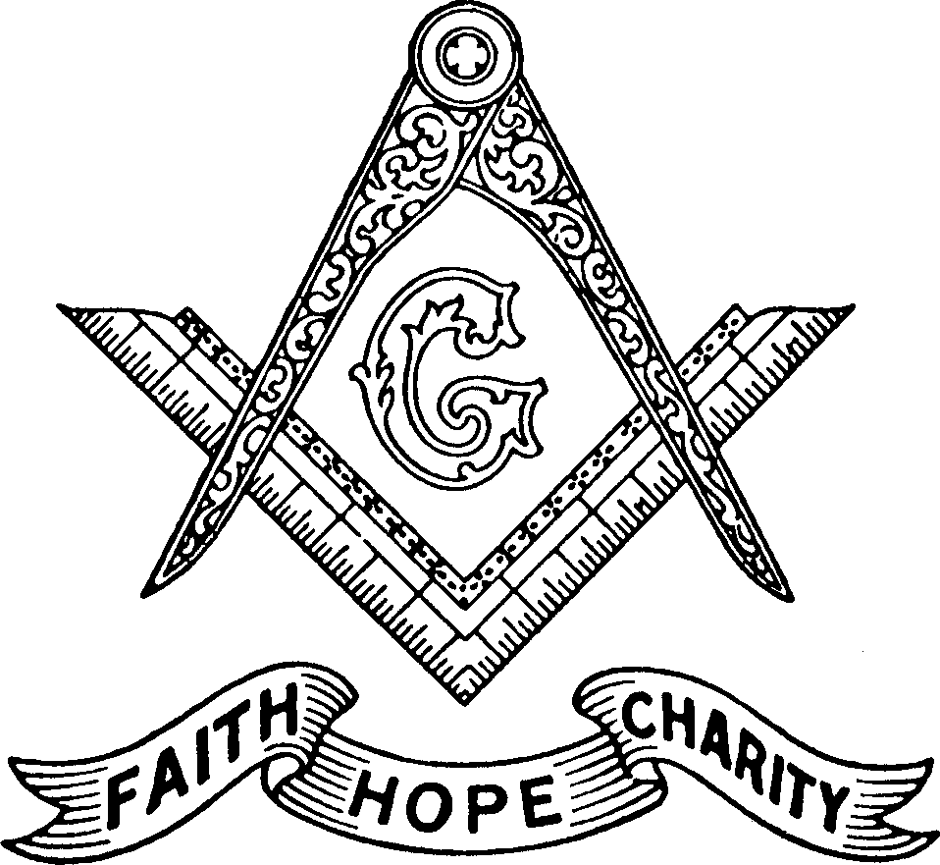
Tiler
Jeremy Johnson
Marshall
Mark Goodfellow

Chaplian
Gary Tuccio, PM

Treasurer
Earl Ebert, PM

Secretary
Steve Saxton, PM
203-725-2914

Jr. Steward
John Vergnetti

Sr Steward
Kyle Taraskewich

Jr. Warden
Michael Messner
203-558-4012
Junior Deacon
Pete Cavanaugh
Sr. Warden
Chad Mullins
203-494-3534
203
Worshipful Master
Scott Tomlinson
203-410-6701
Senior Deacon
Alex Defranzo

Mason Trestle Board
September - December 2024

Monthly Stated Communications
1st Saturday, 7:30PM
3rd Thursday, 7:30PM
(except July & August)

Morning Star Lodge #47
419 Corum Avenue,
Shelton CT
06484

If you need a ride to lodge, let us know!

The most important part of any Masonic gathering is not the business, but the fellowship. We have meals before meetings to foster this fellowship.

This lodge is your lodge, and your friends are welcome— bring them to dinner. Please come out and enjoy the fellowship.

Masonic Birthdays
From the East

Brether of Morning Star Lodge #47,

Brothers,
As we return from the summer break, I’d like us to focus on events and fellowship for the rest of the year, to continue strengthening our brotherhood and involving our families even more. We have a busy schedule ahead, and I’m hopeful that together, we’ll be able to accomplish everything we’ve planned.

Fraternally,
Scott Tomlinson
Worshipful Master

Name | Years | Date Raised |  | Name | Years | Date Raised
Seth Davis | 7 | 4/8/2017 |  | Earl Ebert | 15 | 6/16/2009
Stephen Leonetti | 7 | 4/8/2017 |  | Randy Bruce | 30 | 6/7/1994
Robert Erff | 5 | 4/6/2019 |  | Gary Tuccio | 9 | 10/17/2015
Scott Tomlinson | 5 | 4/6/2019 |  | Perry Bartovic | 9 | 10/17/2015
Jason Cedor | 3 | 4/10/2021 |  | Stephen Saxton | 9 | 10/17/2015
Cody Rawling | 3 | 4/10/2021 |  | Peter Rosendahl | 47 | 10/5/1977
Mark Goodfellow | 1 | 4/8/2023 |  | David Sorman | 54 | 10/28/1970
Michael Clavarino | 8 | 05/17/16 |  | Stanton Johnson | 55 | 11/7/1969
Donald Matejek | 8 | 05/17/16 |  | Robert Peck | 53 | 11/3/1971
Patrick Scukas | 8 | 05/17/16 |  | Elwin Jimmo | 25 | 11/18/1970
Peter Cavanaugh | 3 | 6/5/2021 |  | Neal Miller | 15 | 11/5/1981
Glen Schoenmann | 3 | 6/5/2021 |  | Kenneth Tarwood | 12 | 11/15/2012
Scott Vereb | 11 | 6/1/2013 |  | Michael Wilhelm | 28 | 12/7/1996

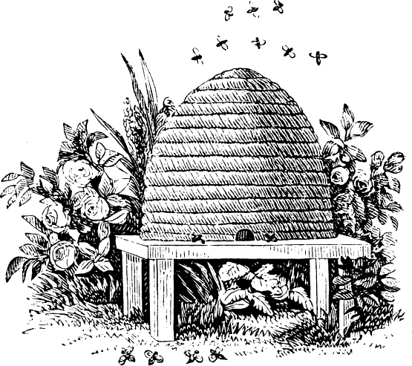

A mason does what he does to better him- self and help others without expecting any- thing in return—what are you doing?

